Project Planning Phase
Project Planning Template (Product Backlog, Sprint Planning, Stories, Story points)
Date | 30 September 2026
Team ID | SWUID2026286057
Project Name | Implement Client Script & UI Policy (Incident)
Maximum Marks | 5 Marks

Product Backlog, Sprint Schedule, and Estimation (4 Marks)
Product backlog and sprint schedule for the ServiceNow Administrator project "Implement Client Script & UI Policy (Incident)".
Sprint | Functional Requirement (Epic) | User Story Number | User Story / Task | Story Points | Priority | Team Members
Sprint-1 | Setup & Requirement Analysis | USN-1 | As an admin, I can set up the ServiceNow Personal Developer Instance (PDI) and log in to access the Incident module. | 2 | High | Naveen.R
Sprint-1 | Setup & Requirement Analysis | USN-2 | As an admin, I can create an Update Set (Incident_ClientScript_UIPolicy) to capture all customizations. | 1 | High | Rudhran.S.N
Sprint-1 | Setup & Requirement Analysis | USN-3 | As an admin, I can analyze the Incident form and identify the fields that need validation and dynamic behavior. | 3 | High | Ramesh.M
Sprint-1 | Setup & Requirement Analysis | USN-4 | As an admin, I can configure the Incident form layout and fields required for the use case. | 2 | Medium | Vivilian Joshua.A
Sprint-2 | UI Policy Implementation | USN-5 | As an admin, I can create a UI Policy that makes Short description mandatory when State is New. | 3 | High | Naveen.R
Sprint-2 | UI Policy Implementation | USN-6 | As an admin, I can create a UI Policy that makes Resolution code and Resolution notes mandatory when State is Resolved. | 3 | High | Sarathi.S
Sprint-2 | UI Policy Implementation | USN-7 | As an admin, I can create a UI Policy that keeps Assigned to read-only until Assignment group is selected. | 2 | Medium | Rudhran.S.N
Sprint-2 | UI Policy Implementation | USN-8 | As an admin, I can configure UI Policy conditions, UI Policy Actions and the 'Reverse if false' and 'On load' options. | 2 | Medium | Ramesh.M
Sprint-3 | Client Script Implementation | USN-9 | As an admin, I can create an onChange Client Script on Category that clears Subcategory and shows an information message. | 3 | High | Vivilian Joshua.A
Sprint-3 | Client Script Implementation | USN-10 | As an admin, I can create an onChange Client Script on Priority that shows a warning when Priority is 1 - Critical. | 3 | Medium | Sarathi.S
Sprint-3 | Client Script Implementation | USN-11 | As an admin, I can create an onLoad Client Script that shows a message and sets default values on a new Incident form. | 2 | Medium | Naveen.R
Sprint-3 | Client Script Implementation | USN-12 | As an admin, I can create an onSubmit Client Script that validates Short description length and stops submission with an error message. | 5 | High | Rudhran.S.N
Sprint-4 | Testing & Documentation | USN-13 | As a tester, I can verify all UI Policies with positive and negative test cases on the Incident form. | 3 | High | Ramesh.M
Sprint-4 | Testing & Documentation | USN-14 | As a tester, I can verify the onLoad, onChange and onSubmit Client Scripts on the Incident form. | 3 | High | Vivilian Joshua.A
Sprint-4 | Testing & Documentation | USN-15 | As a team, we prepare the documentation, screenshots and project report. | 2 | Medium | Sarathi.S
Sprint-4 | Testing & Documentation | USN-16 | As an admin, I can finalize the Update Set and complete the final review and demo. | 1 | Medium | Naveen.R
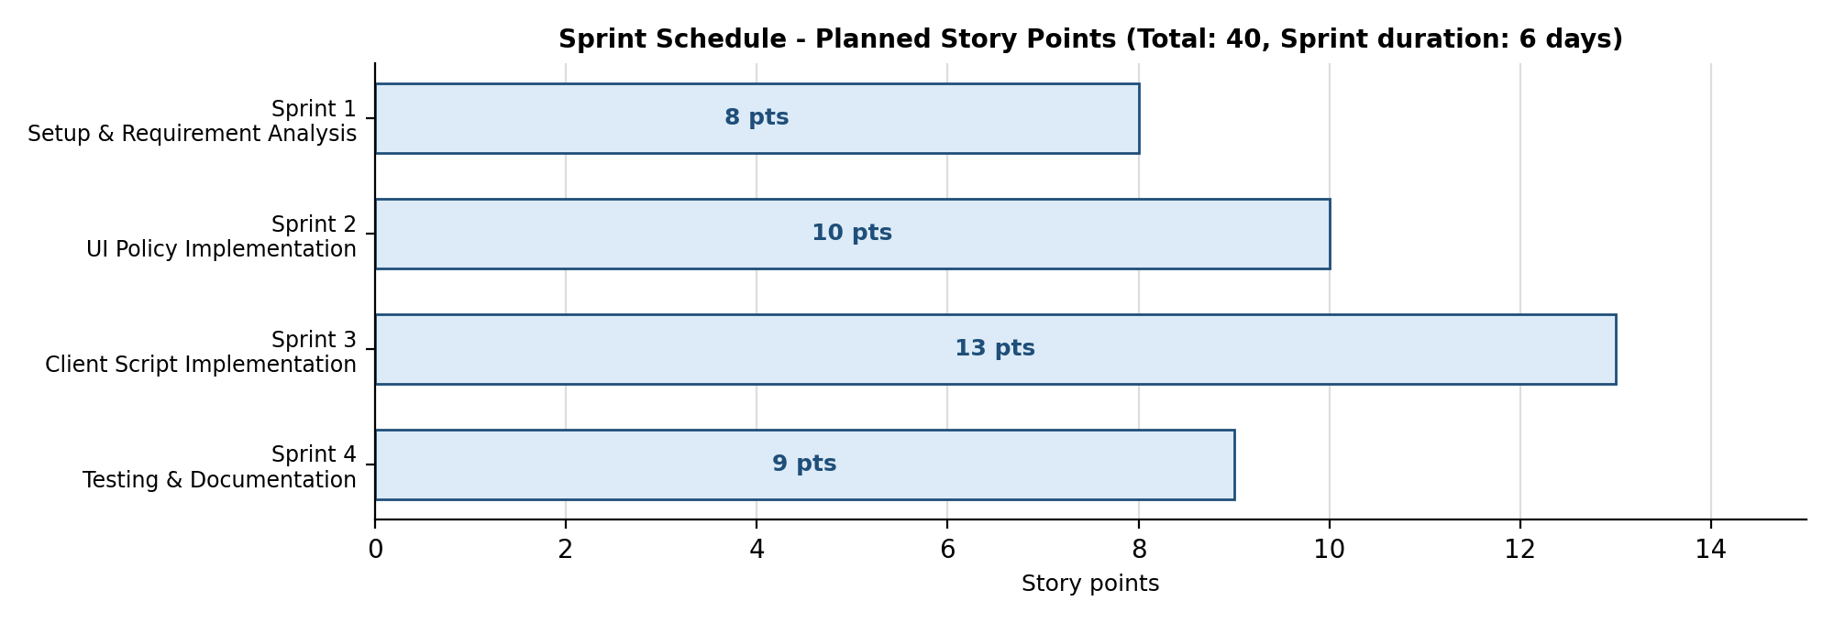
Figure 1: Sprint schedule and story-point representation.

Planning Logic
Sprint | A fixed period in which the team completes a set of tasks. Sprint duration = 6 days.
Epic | A big task that is broken into smaller stories: Setup & Analysis, UI Policy, Client Script, Testing & Documentation.
Story (USN) | A small task that belongs to an Epic. This project has 16 user stories (USN-1 to USN-16).
Story Point | Effort needed for a story, using the scale 1, 2, 3, 5: 1 = Very Easy, 2 = Normal, 3 = Moderate, 5 = Difficult.
Sprint totals | Sprint-1 = 2+1+3+2 = 8; Sprint-2 = 3+3+2+2 = 10; Sprint-3 = 3+3+2+5 = 13; Sprint-4 = 3+3+2+1 = 9. Total = 8+10+13+9 = 40 story points.
Velocity | Velocity = Total Story Points Completed / Number of Sprints = 40 / 4 = 10 story points per sprint.

Project Tracker, Velocity & Burndown Chart: (4 Marks)
Sprint | Total Story Points | Duration | Sprint Start Date | Sprint End Date (Planned) | Story Points Completed (as on Planned End Date) | Sprint Release Date (Actual)
Sprint-1 | 8 | 6 Days | 31 Aug 2026 | 05 Sep 2026 | 8 | 05 Sep 2026
Sprint-2 | 10 | 6 Days | 07 Sep 2026 | 12 Sep 2026 | 10 | 12 Sep 2026
Sprint-3 | 13 | 6 Days | 14 Sep 2026 | 19 Sep 2026 | 13 | 19 Sep 2026
Sprint-4 | 9 | 6 Days | 21 Sep 2026 | 26 Sep 2026 | 9 | 26 Sep 2026
Total | 40 | 24 Days |  |  | 40
Work Item Tracker
Work Item | Status | Validation
ServiceNow PDI and Incident module access | Completed | PDI active; admin login successful; Incident module opens.
Update Set | Completed | Update Set Incident_ClientScript_UIPolicy created and set as current.
Incident form analysis and layout | Completed | Fields identified and form layout configured.
UI Policy - Short description mandatory | Completed | Short description is mandatory when State is New.
UI Policy - Resolution fields mandatory | Completed | Resolution code and Resolution notes mandatory when State is Resolved.
UI Policy - Assigned to read-only | Completed | Assigned to is read-only until Assignment group is selected.
Client Script - onLoad | Completed | Message displayed and defaults set on a new Incident form.
Client Script - onChange (Category) | Completed | Subcategory cleared and message shown when Category changes.
Client Script - onChange (Priority) | Completed | Warning shown when Priority is 1 - Critical.
Client Script - onSubmit | Completed | Submission blocked with error message when Short description is too short.
Testing | Completed | UI Policies and Client Scripts validated with positive and negative cases.
Documentation and Update Set | Completed | Report, screenshots prepared; Update Set finalized.

Velocity:
Sprint duration = 6 days and total story points = 40 over 4 sprints, so the team's velocity is 40 / 4 = 10 story points per sprint.
Average Velocity (AV) per iteration unit (story points per day) = Velocity / Sprint duration = 10 / 6 = 1.67 story points per day.

Burndown Chart:
A burn down chart is a graphical representation of work left to do versus time. The chart below shows remaining story points (out of 40) at the end of each sprint against the ideal burndown line.
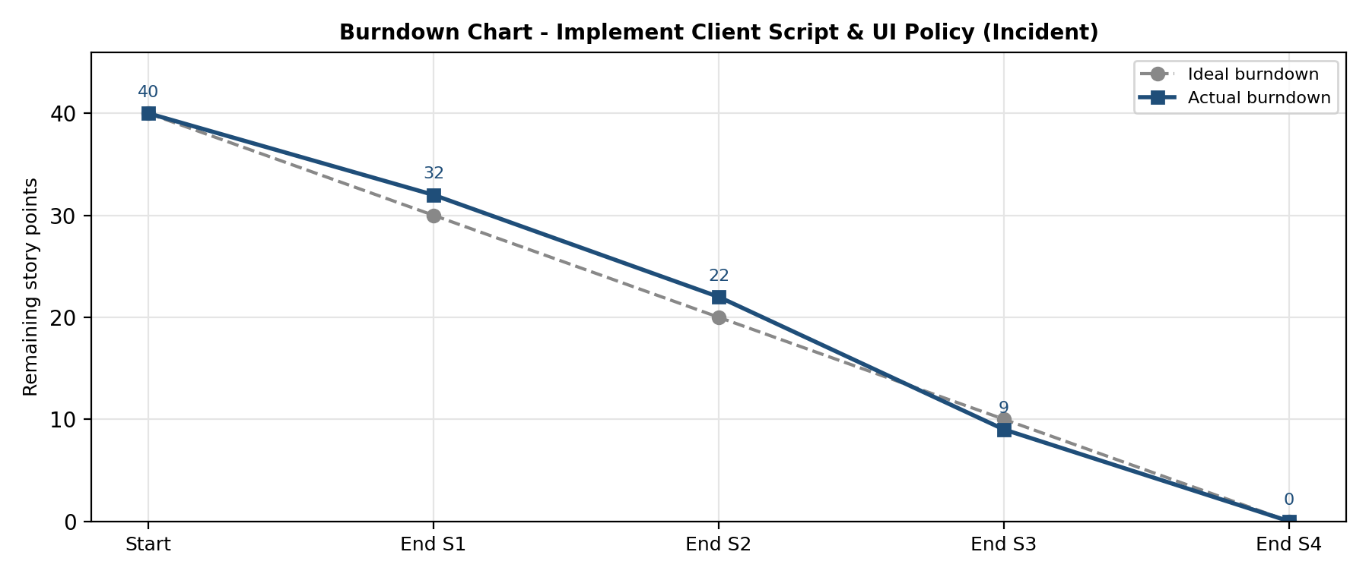
Figure 2: Burndown chart for the project.
https://www.visual-paradigm.com/scrum/scrum-burndown-chart/
https://www.atlassian.com/agile/tutorials/burndown-charts

Reference:
https://www.atlassian.com/agile/project-management
https://www.atlassian.com/agile/tutorials/how-to-do-scrum-with-jira-software

